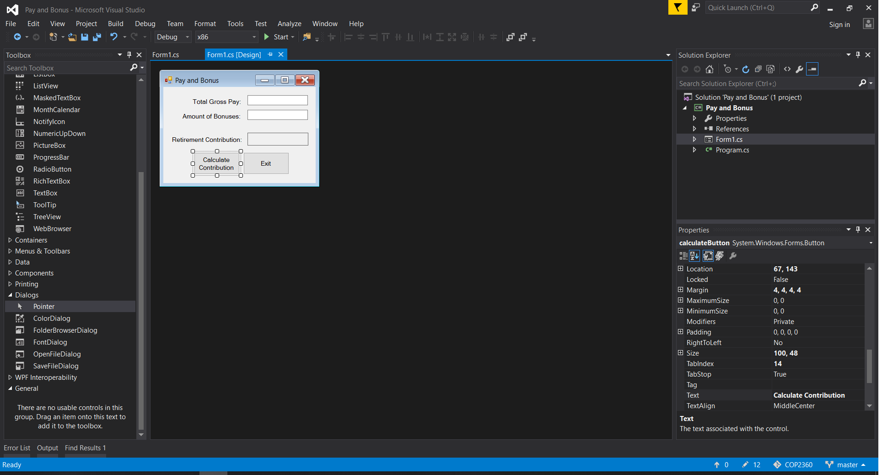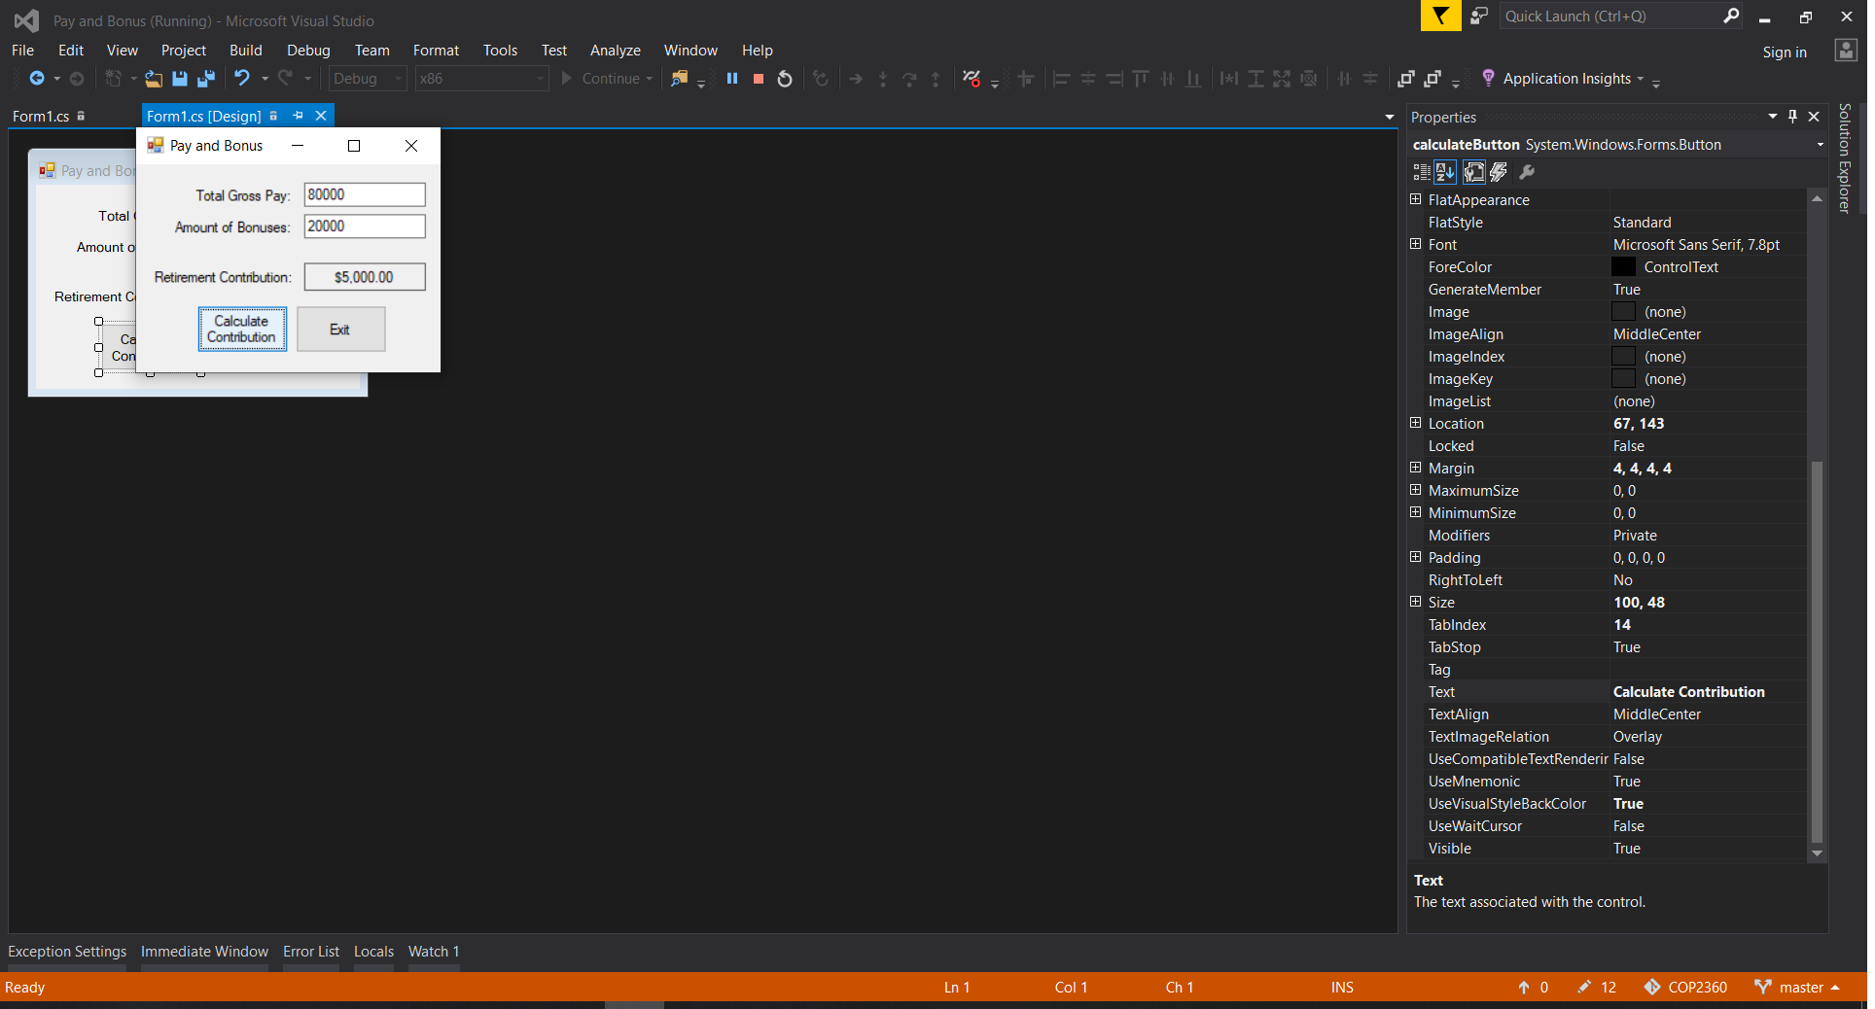

using System;

using System.Collections.Generic;

using System.ComponentModel;

using System.Data;

using System.Drawing;

using System.Linq;

using System.Text;

using System.Windows.Forms;

namespace Pay_and_Bonus

{

public partial class Form1 : Form

{

//create a constant filed for the contribution rate

private const decimal CONTRIB_RATE = 0.05m;

public Form1()

{

InitializeComponent();

}

private void exitButton_Click(object sender, EventArgs e)

{

this.Close();

}

private void calculateButton_Click(object sender, EventArgs e)

{

// create variable for gross pay, bonus and the contributions

decimal grossPay = 0m, bonus = 0m, contributions = 0m;

if (InputIsValid(ref grossPay, ref bonus))

{

//calculate the total amount of contribution

contributions = (grossPay + bonus) * CONTRIB_RATE;

//display the contributions value

contributionLabel.Text = contributions.ToString("c");

}

}

//the InputIsValid method will convert the user's input and store

//it in the arguments that are passed by reference. If the conversion

//is successful, the method returns true. Otherwise false.

private bool InputIsValid(ref decimal pay, ref decimal bonus)

{

bool inputIsGood = false;

// try to convert both inputs to a decimal

if (decimal.TryParse(grossPayTextBox.Text, out pay))

{

if (decimal.TryParse(bonusTextBox.Text, out bonus))

{

//since both are good then set inputIsGood to true

inputIsGood = true;

}

else

{

//display an error for the bonus input

MessageBox.Show("Bonus amount is invalid");

bonusTextBox.Text = "";

bonusTextBox.Focus();

}

}

else

{

MessageBox.Show("Grosspay amount is invalid.");

grossPayTextBox.Text = "";

grossPayTextBox.Focus();

}

return inputIsGood;

}

}

}